Biography - Short
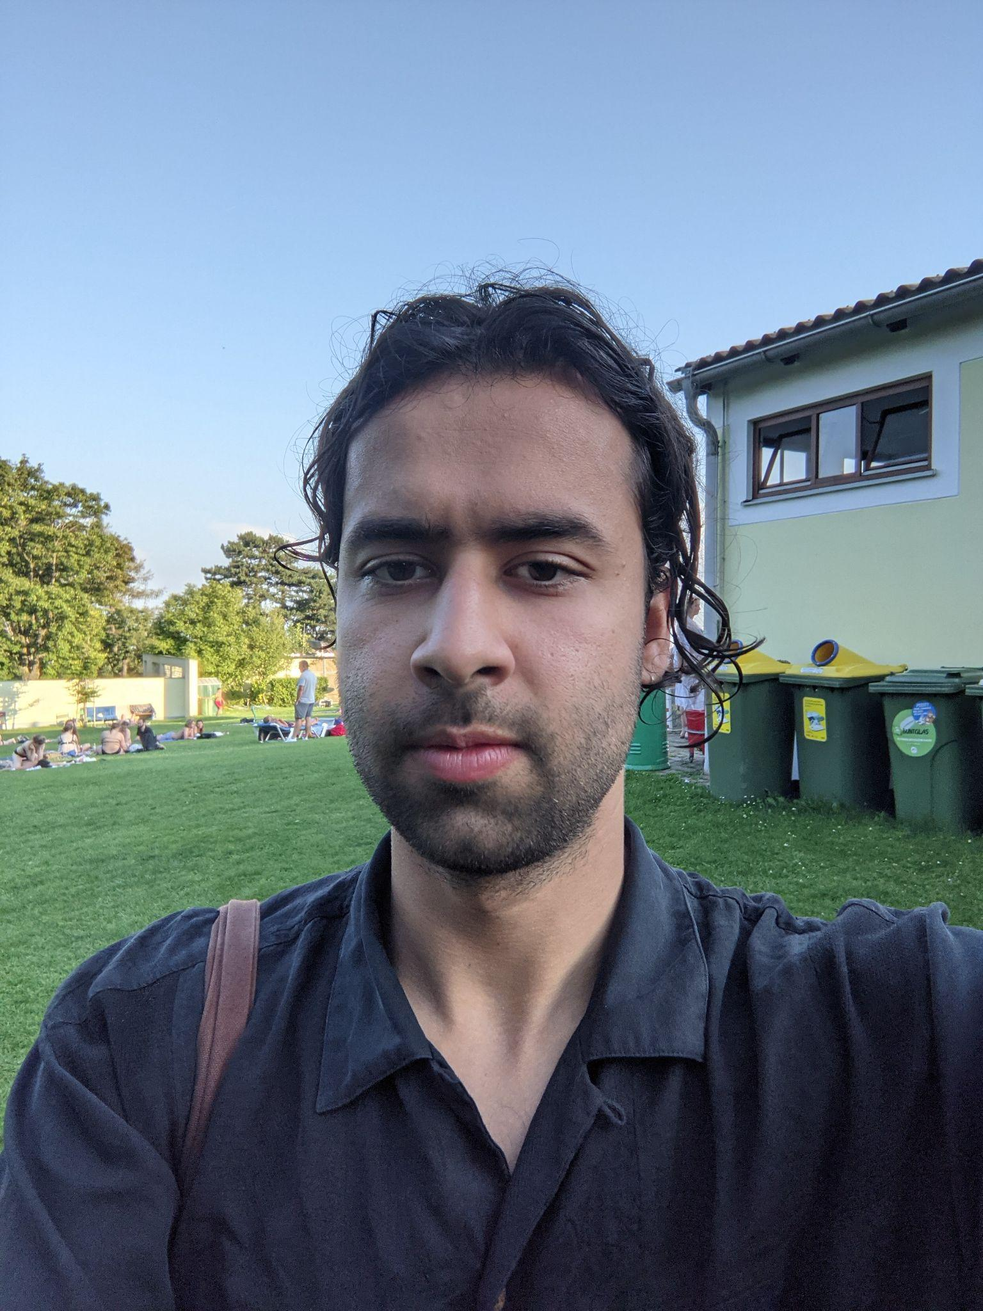
850CH
Armin Hokmi is an artist working with live performance between theater and dance. He began his artistic works in 2009 as a performer with independent theater in Rasht, Iran. He later continued to work and study abroad toward experiences with multiple performative practices, mediums and expressions. He holds a B.A. in acting from Norwegian Theatre Academy (2015-2018) and has received his M.A. in Solo/Dance/Authorship at HZT Berlin (2019-2021).

Working through text, dances and choreographies, recent works include Passages (2019), Public Dance, Permutable Stage (2021) and International Dance (2022) which premiered at Uferstudios in Berlin.
As a dancer and performer he has worked with artists such as Mette Ingvartsen, Kasper Ravnhøj, Hooman Sharifi and Phillip Zarrilli among others. Armin currently lives and works in Berlin.

Contact: Arminhokmi@gmail.com

Shorter Version: 600CH
Armin Hokmi is an artist working with live performance between theater and dance. He began his artistic works in 2009 as a performer with independent theater in Iran. He later continued to work and study abroad toward experiences with multiple performative practices, mediums and expressions. He has received his M.A. in Solo/Dance/Authorship at HZT Berlin. His recent projects Public Dance, Permutable Stage (2021) and International Dance (2022) premiered at Uferstudios in Berlin. As a dancer he has worked with artists such as Mette Ingvartsen, Kasper Ravnhøj, Hooman Sharifi among others.
Contact: Arminhokmi@gmail.com

