### **Biography**

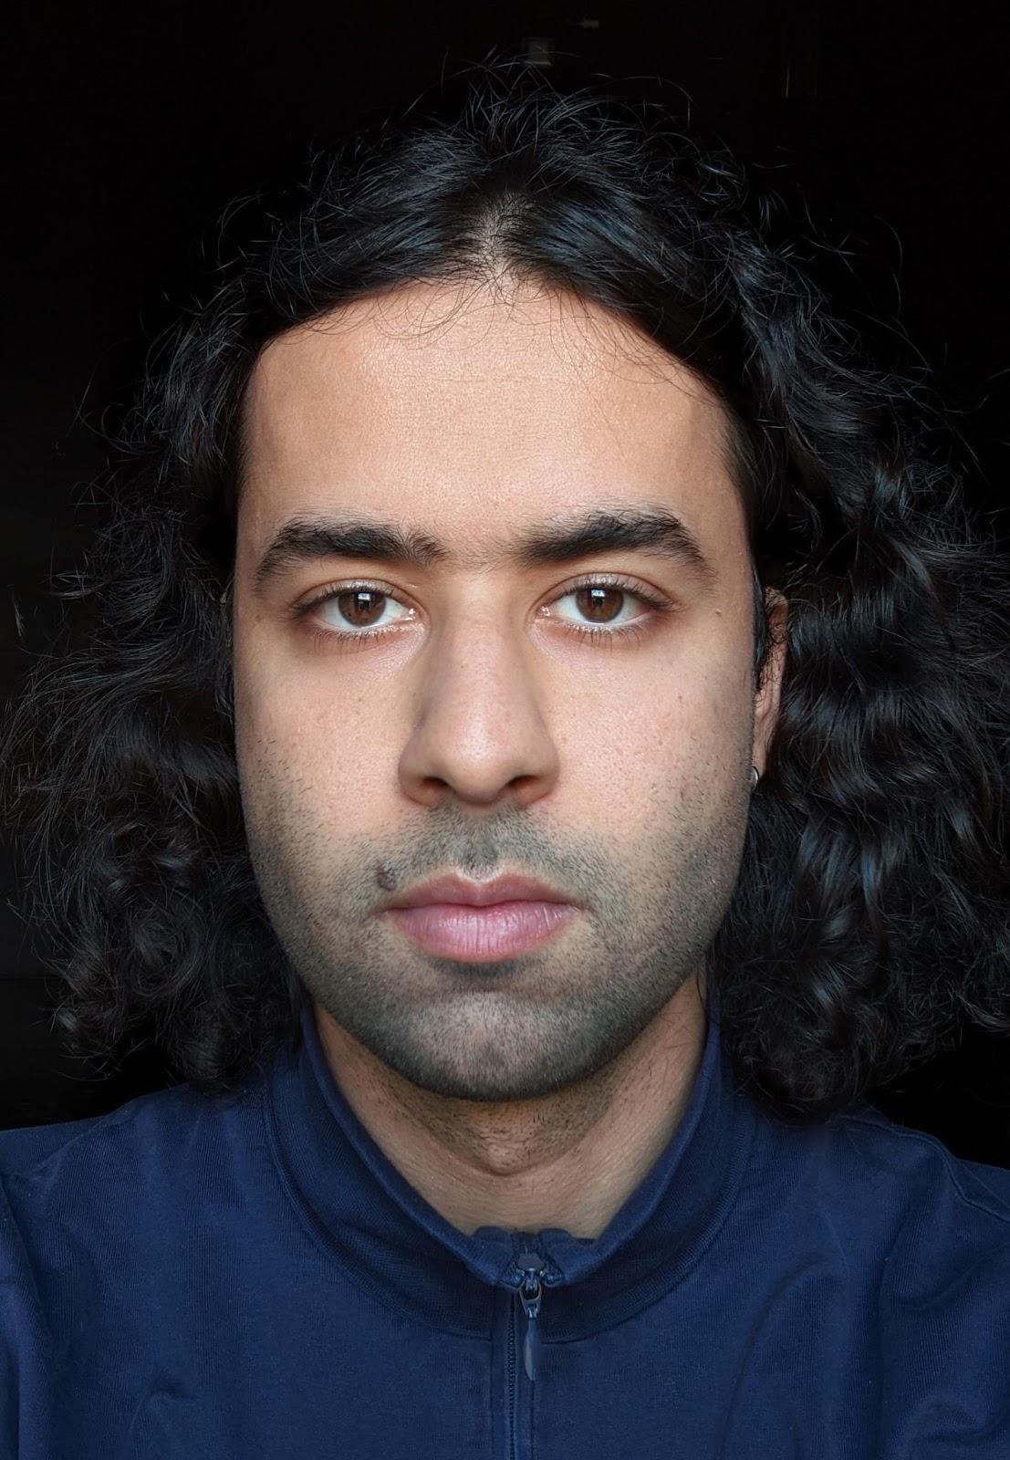

**Armin Hokmi** is working with dance and choreography. He began in 2009 as a performer with independent theater in Iran and later continued to work and study abroad toward experiences with multiple performative practices and mediums. He holds a B.A. in acting from Norwegian Theatre Academy (2015-2018) and has received his M.A. in Solo/Dance/Authorship at HZT Berlin (2019-2021).

In a time when an imaginable public for dance is under the effect of new economies of attention and participation, he is focused on how to work with dance and choreography as interfaces and tools for proposing distinct modes of public address. In the light of this question, he is currently interested in probing the frames of presentation and conventions as a way to examine the ways in which dance and choreography meet the public; And how those frames shape the audience's experience and conception of dance and choreography. With his broad background in live arts, and wide understanding of stage expressions, he is dedicated to dance and choreography and their autonomy as mediums.

In parallel, Armin's dance and movement language is an interplay between a sense of familiarity with known forms, and practices that elude recognition. Cultivating a horizon where different possibilities of referentiality converge in contrast and alteration. Particularly and in concern for dances that have been neglected and deemed unworthy of historical significance. His choreographic practice embarks throughout time and space, overflowing attention and persuading change through the constant unfolding of the dance into new trajectories.

His recent works include *Passages* (2019), *Public Dance, Permutable Stage* (2021), *International Dance* (2022) and *Shiraz* (2024).

As a dancer and performer he has worked with artists such as Mette Ingvartsen, Kasper Ravnhøj, Hooman Sharifi and Phillip Zarrilli among others. Armin is an associate artist at Montpellier Danse for 2024-2026.  
  
For the upcoming years he focuses on a solo work for the dancer Daniel Sarr in *What About the Heart* (2025) and *Repertoire-(Bazm)* (2026) a choreography for 11 dancers. Armin continues his dedication to cultivating an international network of collaborations and partners for these projects to establish a vibrant, dynamic, translocal and sustainable environment for the team. He remains dedicated to bringing together dancers and artists from different training backgrounds, contexts and abilities to generate new modes of collaboration, continuity and growth in the field of dance and choreography in his respective contexts.   
  
**Short bio:**

Armin Hokmi is working with dance and choreography. He began his artistic works since 2009 as a performer with independent theater in Rasht, Iran. He later continued to work and study abroad toward experiences with multiple performative practices, mediums and expressions. He holds a B.A. in acting from Norwegian Theatre Academy (2015-2018) and has received his M.A. in Solo/Dance/Authorship at HZT Berlin (2019-2021). Armin is an associated artist at Montpellier Danse 2024-2026.

Working through text, dances and choreographies, recent works include Passages (2019), Public Dance, Permutable Stage (2021) and International Dance (2022) which premiered at Uferstudios in Berlin.

As a dancer and performer he has worked with artists such as Mette Ingvartsen, Kasper Ravnhøj, Hooman Sharifi and Phillip Zarrilli among others.